
Murray Bridge High School
Year 9 Digital Technology
Summative Task 1: Pythag Calc

Description of Assessment:
You have been chosen! Pythagoras Phan club Australia has chosen you to create their brand new Pythagoras’ theorem calculator!

Pythagoras’ Theorem is used to solve the length the Hypotenuse (the longest side) of a right angle triangle (represented by ‘C’ in the diagram).

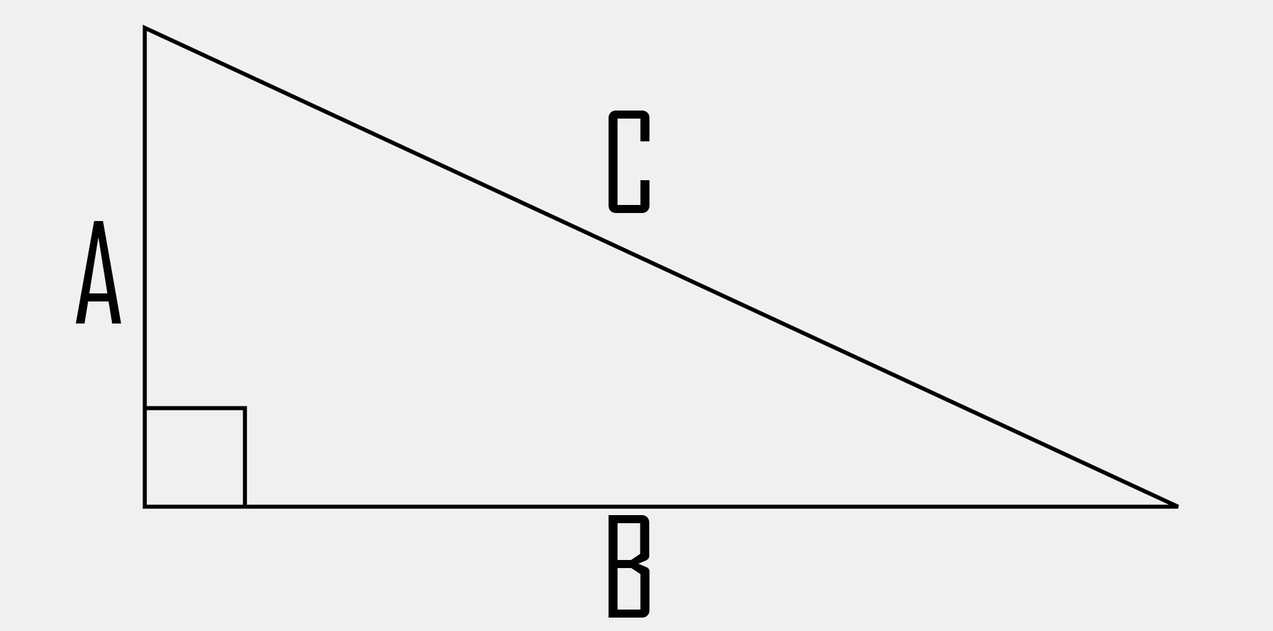

The theorem is as follows: $a^{2}+b^{2}=c^{2}$
So, if A = 4 and B = 3 the theorem would be solved like the following:
$$4^{2}+3^{2}=c^{2}$$
$$16+9=c^{2}$$
$$25=c^{2}$$
$$c^{2}=25$$
$$c^{}=√25$$
$$c^{}=5$$
The final length of C is 5.

Simple Aim
Your aim is to create a calculator that when given A and B it is able to calculate the length of C. Give the calculator the ability to clear.
Intermediate Aim
Pythagoras’s Theorem is able to also calculate the length of a missing side if provided with the length of the Hypotenuse and one of the side. Add this functionality to your calculator.
Complex Aim
There are many errors that can occur with his calculator. For example, when trying to find the length of a side that is not the Hypotenuse the user can input in a value that is larger than the Hypotenuse for the known side, this will cause and error. Instead of having this error occur check and prompt the user to change the number before the calculator will allow the calculation to occur.
Likewise, find a way to stop users from entering text into fields.

